

Dr. Brian, Chambers inc.

2017-04-07

Dr. Chambers

PSC 4001, Box 2686, APO AA 77790

Phone: 1385819858

Fax: 4206158675

**Re:** Brenda, Cook

**PHN:** 6738869015

**Birthdate:** 18-Oct-1982

**Address:** 293 Hurley Trafficway Suite 002, North Davidville, HI 22133

**Patient number:** 3005825563

To Whom It May Concern:

This is a medical letter to state the above patient is pregnant with expected delivery date of 07-Jun-2025. Hoping this information is satisfactory for your requirements.

Thank you.

Sincerely,

Dr. Brian, Chambers

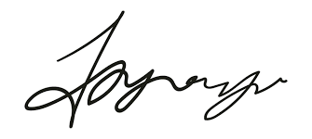

FRCS© NCMP

Clinical Assistant Professor, UBC

Department of Obstetrics and Gynecology SMH